Adriana Rodriguez

11/19/23

CSD 310 Module 6.2 Assignment

###### **Assignment: Movies: Setup**

###### **6. Instructions**

* Before proceeding any further, make sure you have completed the checklist.
* Start MySQL and activate the **movies** database.
* Run the **db_init_2022.sql** file.
  + Take a screenshot of the output from running that .sql file, and of the show tables command.

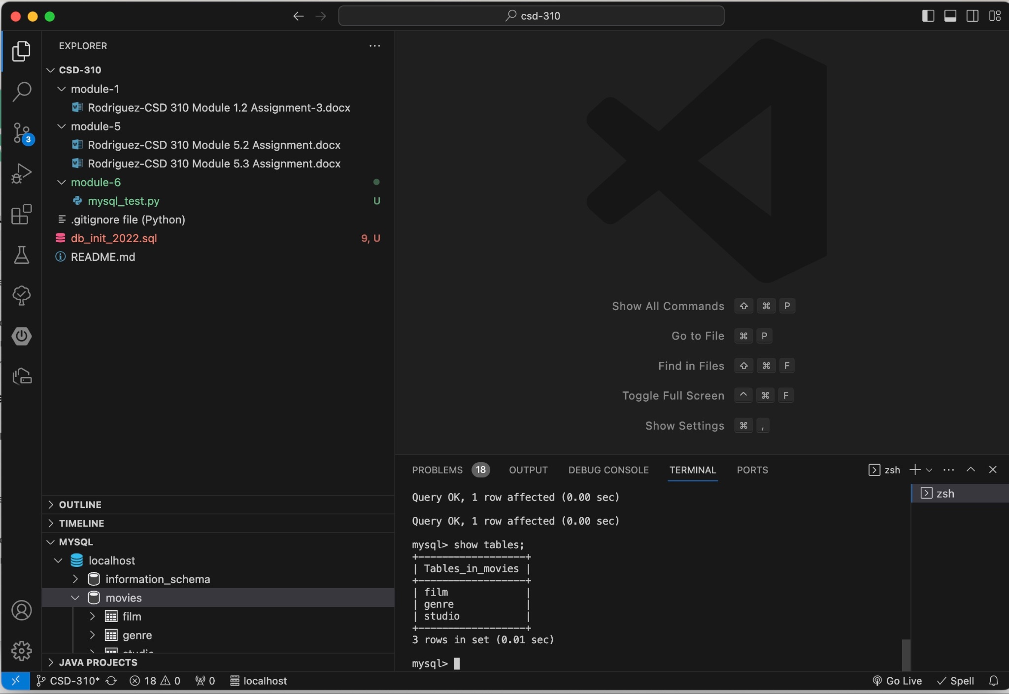

* Create a new directory under **csd-310** and name it **module_6**.
* Under the **module_6 directory**, create a new file and name it **mysql_test.py**.
* Using the coding example I provided, create a new Python program that connects to the movies database.
  + Run the connect program, and take a screenshot of the output.

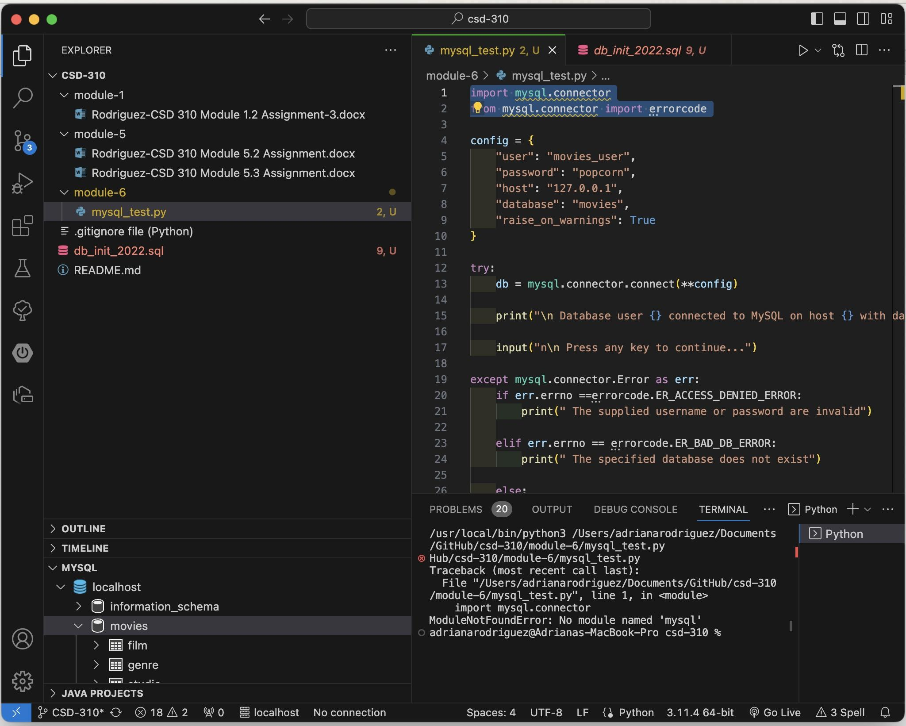

* Combine all images in a single word document and include your name, date, and assignment number.

###### **7. GitHub**

* Read through the GitHub tutorial at W3Schools. Basically this will be a three-step process. Add the files (stage), commit the files, then push the files.
* Stage, commit, and push your work to GitHub.

###### **8. Deliverable**

* Combine the images and your link to the GitHub repository into a single word document and include your name, date, and assignment.

[git@github.com](mailto:git@github.com):nanirdz/csd-310.git

* Save your document as <your-last-name>-<assignment-name> .docx.
* mysql_test.py